|  |  |
| --- | --- |
| [KAN-5]  [The link of the article content isn't active](https://tmelnychok30.atlassian.net/browse/KAN-5) Created: 15/вер./24  Updated: 15/вер./24 | |
| **Status:** | To Do |
| **Project:** | [Pet-Project AI Guru](https://tmelnychok30.atlassian.net/secure/BrowseProject.jspa?id=10000) |
| **Components:** | None |
| **Affects versions:** | None |
| **Fix versions:** | None |

|  |  |  |  |
| --- | --- | --- | --- |
| **Type:** | Bug | **Priority:** | Medium |
| **Reporter:** | [Tetiana Melnychok](https://tmelnychok30.atlassian.net/secure/ViewProfile.jspa?accountId=712020%3A4e68e605-a434-4948-bfa8-bb53c39de0a3) | **Assignee:** | [Tetiana Melnychok](https://tmelnychok30.atlassian.net/secure/ViewProfile.jspa?accountId=712020%3A4e68e605-a434-4948-bfa8-bb53c39de0a3) |
| **Resolution:** | Unresolved | **Votes:** | 0 |
| **Labels:** | functional | | |
| **Remaining Estimate:** | Not Specified | | |
| **Time Spent:** | Not Specified | | |
| **Original estimate:** | Not Specified | | |

|  |  |
| --- | --- |
| **Attachments:** | image.png |
| **Issue links:** | |  |  |  |  | | --- | --- | --- | --- | | **Blocks** | | | | | is blocked by | [~~KAN-6~~](https://tmelnychok30.atlassian.net/browse/KAN-6) | Testing the functionality of the art... | Done | |
| **Rank:** | 0|i0000n: |

|  |  |
| --- | --- |
| **Description** |  |

|  |
| --- |
| **Steps:** 1. Follow the link: <https://aiguru.com.ua/flux-neymovirni-mozhlyvosti-u-heneratsiyi-zobrazhen/>; 2. Scroll down the page of the article "Flux - incredible possibilities in image generation" to the beginning of the article content; 3. Click on the 2nd item of the table of contents "Розширені опції на Civitai";  **Expected result:** The link is active; The page with the article scrolls to the corresponding item.  **Actual result:** The link is not active; nothing happens when the user clicks on the link. |

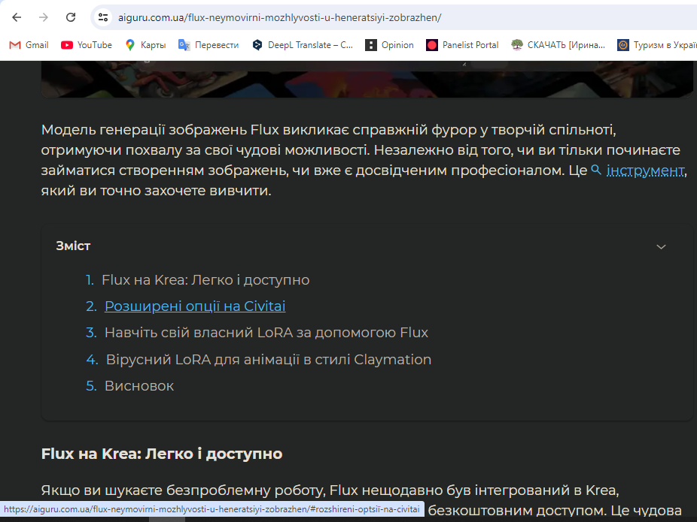

Generated at Tue Sep 17 17:14:35 UTC 2024 by Tetiana Melnychok using Jira 1001.0.0-SNAPSHOT#100266-rev:bccdae9a1b3c45b4ace2d33db0008d855c13cad7.